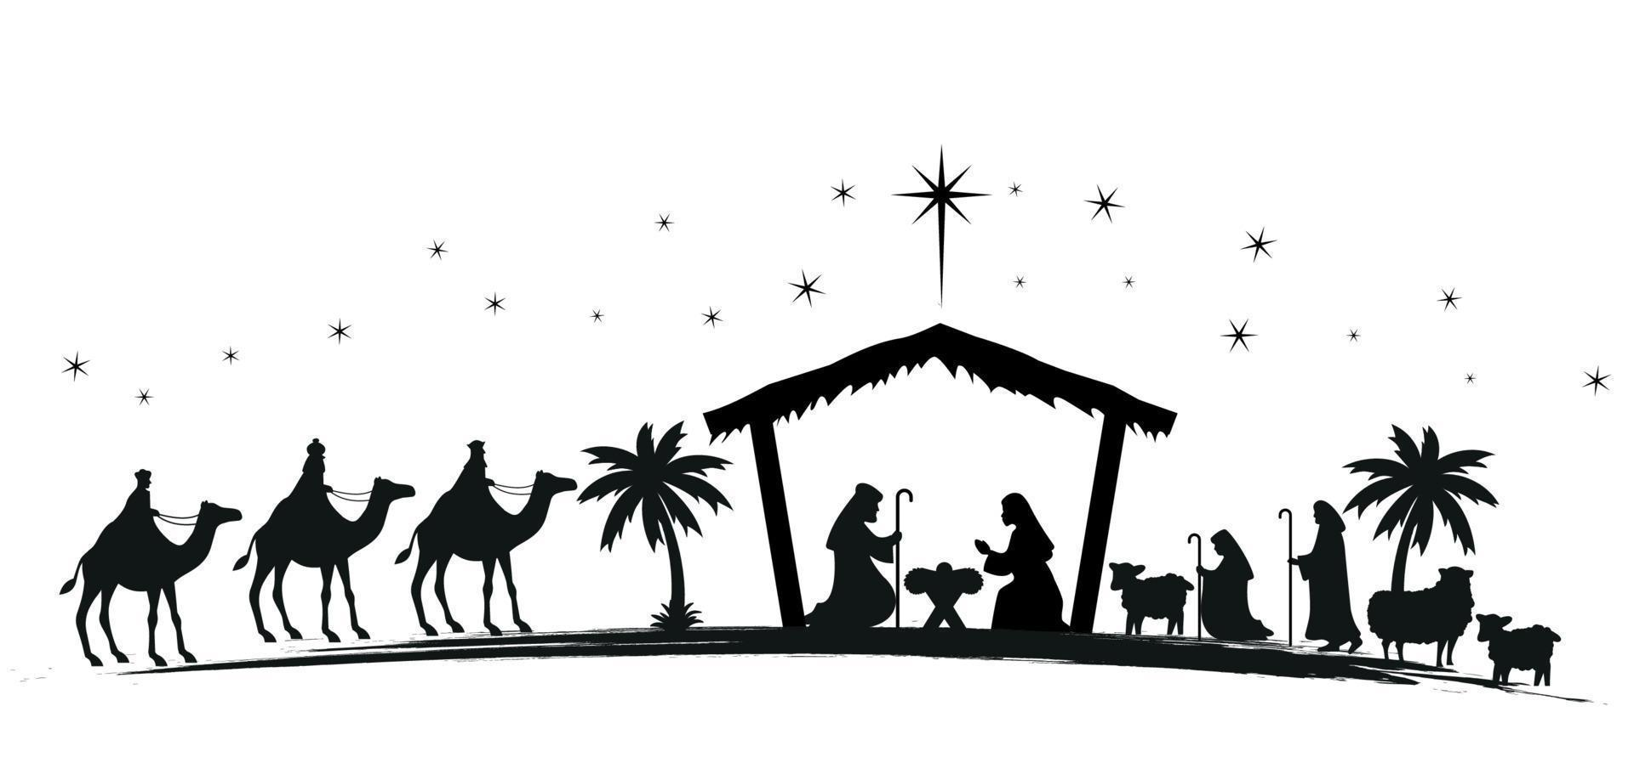

SACRED HEART SRULEEN – CHRISTMAS SCHEDULE
Saturday 13th & 29th Dec. Confessions (Church Prayer Room,) 10.30-11.30 am
Tuesday 16th Dec. Reconciliation Service: Bawnogue Church @ 8 pm
Monday 22nd Dec. Reconciliation Service: Knockmitten Church @ 7.30 pm
Wednesday 24th Dec. Mass at 10 am
Children’s Christmas Eve Mass at 6 pm
Christmas Eve Mass at 9 pm
Thursday 25th Dec. Christmas Day Mass at 11 am
Friday 26th Dec. St Stephen’s Day Mass at 10 am
Saturday 27th Dec. Mass for the Feast of St John the Evangelist at 10 am
Vigil Mass for Feast of the Holy Family at 6.30 pm
Sunday 28th Dec. Mass for the Feast of the Holy Family at 11 am
Tuesday 30th Dec. Mass at 10 am
Wednesday 31st Dec. Mass at 10 am
Thursday 1st Jan. Mass: Feast of Mary, The Holy Mother of God at 10 am
Friday 2nd Jan. Mass at 10 am
Saturday 3rd Jan. Mass at 10 am
Vigil Mass for the 2nd Sunday of Christmas at 6.30 pm
Sunday 4th Jan. Mass for the 2nd Sunday of Christmas at 11 am
Tuesday 6th Jan. Mass for the Feast of the Epiphany at 10 am

